Predict crop yield and compare regions

import pandas as pd
import matplotlib.pyplot as plt
import numpy as np
import seaborn as sns

from sklearn.model_selection import train_test_split
from sklearn.metrics import accuracy_score
from sklearn.linear_model import LogisticRegression
from sklearn.linear_model import LinearRegression
from sklearn.metrics import mean_squared_error, r2_score
df =pd.read_csv("crop_production.csv")
df.head()
df.info
df.describe()
df.isnull().sum()
df.fillna(df.mean(numeric_only=True), inplace=True)
df.head()
plt.figure(figsize=(12,6))
sns.boxplot(data=df)
plt.title("Boxplot")
plt.show()
numeric_df = df.select_dtypes(include=['number'])

Q1 = numeric_df.quantile(0.25)
Q3 = numeric_df.quantile(0.75)
IQR = Q3 - Q1

lower_bound = Q1 - 1.5 * IQR
upper_bound = Q3 + 1.5 * IQR

outliers = ((numeric_df < lower_bound) | (numeric_df > upper_bound))
print("Outliers:", outliers.sum())
df.hist(figsize=(12,10))
plt.title("Histogram")
plt.show()
plt.figure(figsize=(8,5))
sns.heatmap(df.corr(numeric_only=True), annot=True, cmap="coolwarm")
plt.title("Correlation Heatmap")
plt.show()

X = df.drop("Production", axis=1)
y = df["Production"]
X = pd.get_dummies(X)

x_train, x_test, y_train, y_test = train_test_split(X, y, test_size=0.4, random_state=42)
model = LinearRegression()
model.fit(x_train, y_train)
y_pred=model.predict(x_test)
y_pred[:10]
y_pred = model.predict(x_test)
mse = mean_squared_error(y_test, y_pred)
print("MSE:", mse)

r2 = r2_score(y_test, y_pred)
print("R2 Score:", r2)

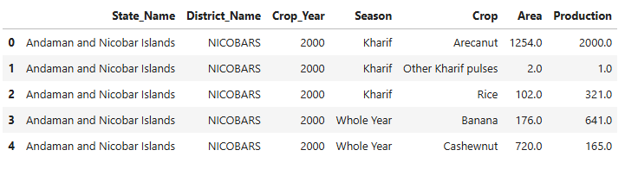
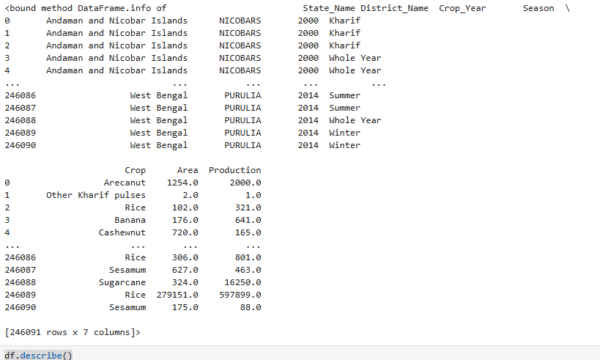
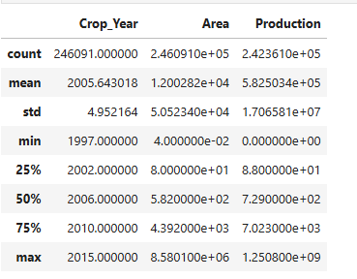
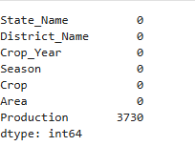
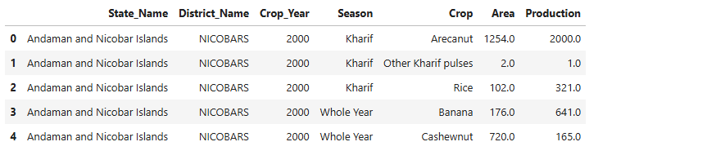
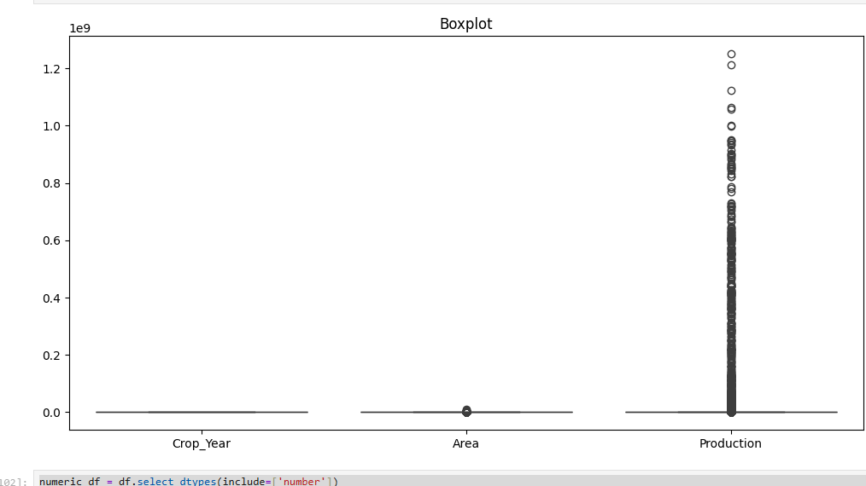

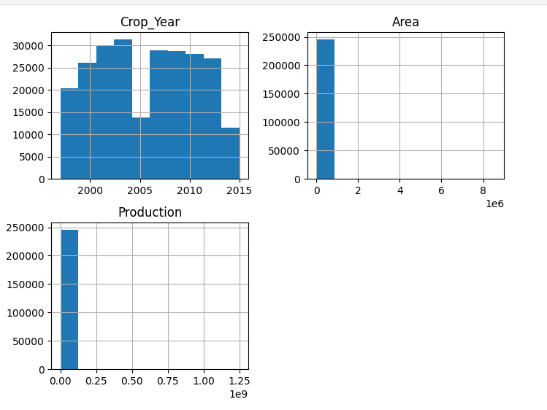

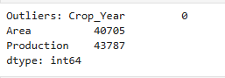
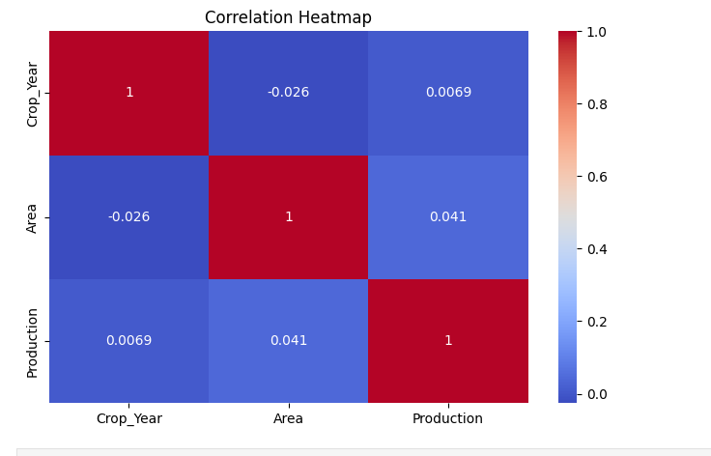

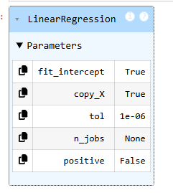
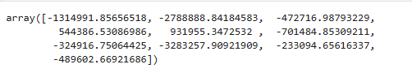

Model Selection
Algorithm Used:
Linear Regression and Logistic Regression were used in this project. Linear Regression is applied to predict continuous crop yield values, while Logistic Regression is used for classification (high or low yield).
Why Chosen:
Linear Regression was chosen because the target variable (Value) is numerical and continuous. Logistic Regression was selected to categorize the yield into binary classes (0 and 1), making the analysis easier to interpret.
Result Obtained:
Linear Regression predicted accurate crop yield values, and Logistic Regression produced outputs like 0 and 1, where 1 indicates high yield and 0 indicates low yield. Model performance was evaluated using R² score and accuracy.

Conclusion:
Thus, appropriate models were selected based on the type of target variable, improving prediction and classification efficiency.

